Student Name : TRAN ANH TAI

Group : TS05

Date : 1/4/2020

LAB 4: ANALZING NETWORK DATA LOG

You are provided with the data file, in .csv format, in the working directory. Write the program to extract the following informations.

Exercise 4A: TOp TALKERS and LISTENERS

One of the most commonly used function in analyzing data log is finding out the IP address of the hosts that send out large amount of packet and hosts that receive large number of packets, usually know as TOP TALKERS and LISTENERS. Based on the IP address we can obtained the organization who owns the IP address.

List the TOP 5 TALKERS

Rank | IP address | # of packets | Organisation
1 | 193.62.192.8 | 3041 | Jisc Services Limited
2 | 155.69.160.32 | 2975 | Nanyang Technological University
3 | 130.14.250.11 | 2604 | National Library of Medicine
4 | 14.139.196.58 | 2452 | National Knowledge Network
5 | 140.112.8.139 | 2056 | National Taiwan University

TOP 5 LISTENERS

Rank | IP address | # of packets | Organisation
1 | 103.37.198.100 | 3841 | A*STAR
2 | 137.132.228.15 | 3715 | National University of Singapore
3 | 202.21.159.244 | 2446 | Republic Polytechnic
4 | 192.101.107.153 | 2368 | ESnet
5 | 103.21.126.2 | 2056 | Indian Institute of Technology Bombay

Exercise 4B: TRANSPORT PROTOCOL

Using the IP protocol type attribute, determine the percentage of TCP and UDP protocol

 | Header value | Transport layer protocol | # of packets
1 | 6 | TCP | 56063
2 | 17 | UDP | 9462
3 | 50 | ESC | 1698
4 | 0 | HOPOPT | 1261
5 | 47 | GREs | 657

The percentage of TCP = 56063 / 69369 x 100 = 80.82%
The percentage of UDP = 9462 / 69369 x 100 = 13.64%

Exercise 4C: ApplicationS PROTOCOL

Using the Destination IP port number determine the most frequently used application protocol.
(For finding the service given the port number https://www.adminsub.net/tcp-udp-port-finder/ )

Rank | Destination IP port number | # of packets | Service
1 | 443 | 13423 | HTTP Secure
2 | 80 | 2647 | HTTP for World Wide Web
3 | 52866 | 2068 | Private / dynamic port
4 | 45512 | 1356 | Private / dynamic port
5 | 56152 | 1341 | Private / dynamic port

Exercise 4D: Traffic

The traffic intensity is an important parameter that a network engineer needs to monitor closely to determine if there is congestion. You would use the IP packet size to calculate the estimated total traffic over the monitored period of 15 seconds. (Assume the sampling rate is 1 in 1000)

Total Traffic( MB) | 64776.32

Exercise 4E: ADDITIONAL ANALYSIS

- Top 5 communication Pair

SRC_IP | DEST_IP | NUMBER
193.62.192.8 | 137.132.228.15 | 3041
130.14.250.11 | 103.37.198.100 | 2599
14.139.196.58 | 192.101.107.153 | 2368
140.112.8.139 | 103.21.126.2 | 2056
137.132.228.15 | 193.62.192.8 | 1910

- Communication between different IP hosts for top 5 pairs:

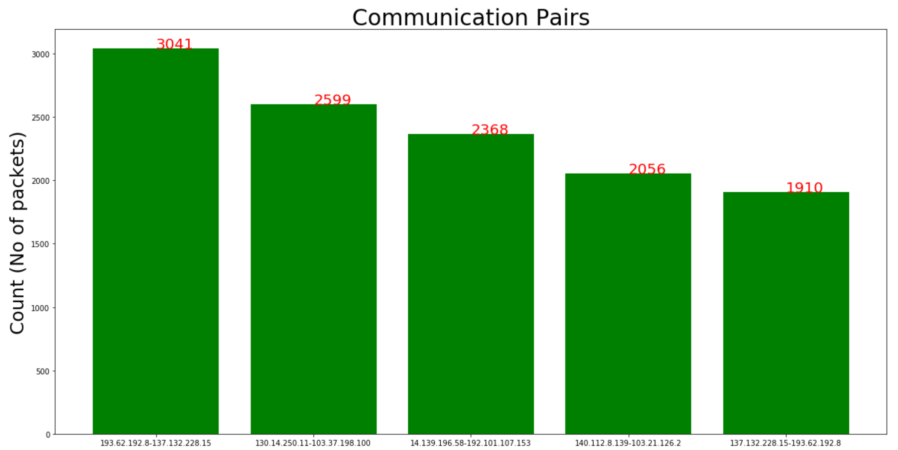

Exercise 4F: SOFTWARE CODE

- A program written in Python in Jupyter Notebook for data exploration and analysis.
- A small part of the code use the geolocation API to retrieve the organization name corresponding to a specific ip address.

